Static Fluids II

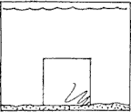
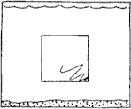
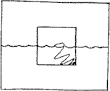
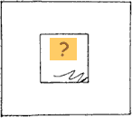
Refer to the following information for the next three questions.
The water lines for the first three cases are shown. Think and then describe where the appropriate water lines should be drawn for cases d and e, and then make up your own situation for case f.
(a) denser than water | (b) same density as water | (c) 1/2 as dense as water | (f) ?
- 1/4th as dense as water:
- 3/4th as dense as water:
- ? as dense as water:

- Refer to the following information for the next three questions.
The first two sketches below show the water line for an empty and loaded ship. Discuss below and describe where the appropriate water line should be drawn for the third sketch.
(Note: 1 metric tonne is 1000 kg and 1 kg is 10 N)

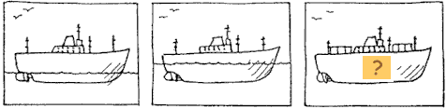

Ship empty | Ship loaded with  50 metric tonnes of iron | Ship loaded with 50 metric tonnes of  styrofoam

  - The third water line should be .

  - If a floating ship weighs 200 million N, then the water it displaces weighs .

  - If cargo weighing 16000 N is put on board then the ship will sink down until an extra of water is displaced.

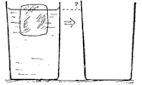
3. Refer to the following information for the next question.

Here is a glass of ice water with an ice cube floating in it. Discuss with your partner where the water line should be drawn after the ice cube melts.
a. Will the water line .

rise | fall | remains the same
- Refer to the following information for the next five questions.
The air-filled balloon is weighted so it sinks in water. Near the surface, the balloon has a certain volume. Think how you should draw the balloon at the bottom (inside the dashed square).

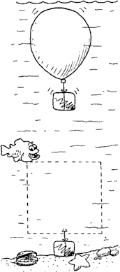
  - State whether it is .

bigger | smaller | the same size

  - Since the weighted balloon sinks, how does its overall density compare to the density of water?

  - As the weighted balloon sinks, does its density .

increase | decrease | remain the same

  - Since the weighted balloon sinks, how does the buoyant force on it compare to its weight?

  - As the weighted balloon sinks deeper, does the buoyant force on it .

increase | decrease | remain the same

- Refer to the following information for the next four questions.

  - What if a rock instead of an air-filled balloon were weighted so that it sinks in water.

Since the weighted rock sinks, how does its overall density compare to the density of water?

- As the weighted rock sinks, does its density .

increase | decrease | remain the same

- Since the weighted rock sinks, how does the buoyant force on it compare to its weight?

- As the weighted rock sinks deeper, does the buoyant force on it .

increase | decrease | remain the same

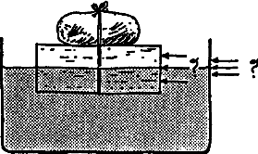

- A block of balsa wood with a rock tied to it floats in water. When the rock is on top as shown, exactly half the block is below the water line.

  - When the block is turned over so the rock is underneath and submerged, the amount of block below the water line is
,

  - less than half
  - half
  - more than half

and the water level at the side of the container will
.

  - rise
  - fall
vii) remain unchanged

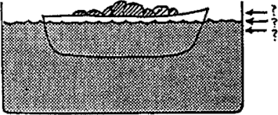

- Consider a boat loaded with scrap iron in a swimming pool. If the iron is thrown overboard into the pool, will the water level at the edge of the pool rise, fall, or remain unchanged?

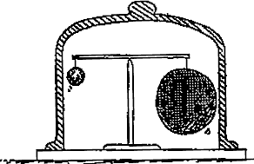

- In the presence of air, the small iron ball and large plastic ball balance each other. When air is evacuated from the container, the larger ball
- rises
- falls
- remains in place
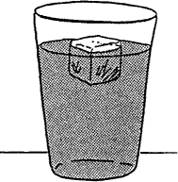

- An ice cube of solid H₂O floats in water. Suppose all the hydrogen in the cube were the heavy isotope of hydrogen, deuterium (H-2). Would the ice cube of solid D₂O float or sink in ordinary water?

